Cryptarithmetic (SEND + MORE = MONEY)
Aim
To solve a Crypt Arithmetic problem using Python by assigning unique digits to letters such that the arithmetic equation is satisfied.
Objective
- To understand the concept of Crypt Arithmetic problems.
- To use Python to generate valid digit assignments.
- To ensure each letter is assigned a unique digit.
- To display the correct solution for the given puzzle.
Algorithm
- Start.
- Import the itertools module.
- Define the letters used in the crypt arithmetic puzzle.
- Generate all possible unique digit assignments.
- Assign digits to each letter.
- Ensure leading letters are not assigned zero.
- Convert the words into numbers.
- Check whether the arithmetic equation is satisfied.
- If a valid solution is found, display the mapping and stop.
- End.

Code:
print("=" * 60)
print(" ARTIFICIAL INTELLIGENCE LAB")
print(" Experiment: Cryptarithmetic Problem")
print(" Name : Vinnarasu R")
print(" Reg No : 192411040")
print("=" * 60)

from itertools import permutations

for p in permutations(range(10), 8):
S, E, N, D, M, O, R, Y = p

if S != 0 and M != 0:
send = 1000 * S + 100 * E + 10 * N + D
more = 1000 * M + 100 * O + 10 * R + E
money = 10000 * M + 1000 * O + 100 * N + 10 * E + Y

if send + more == money:
print("\nSolution Found:")
print("SEND =", send)
print("MORE =", more)
print("MONEY =", money)
break

Output:
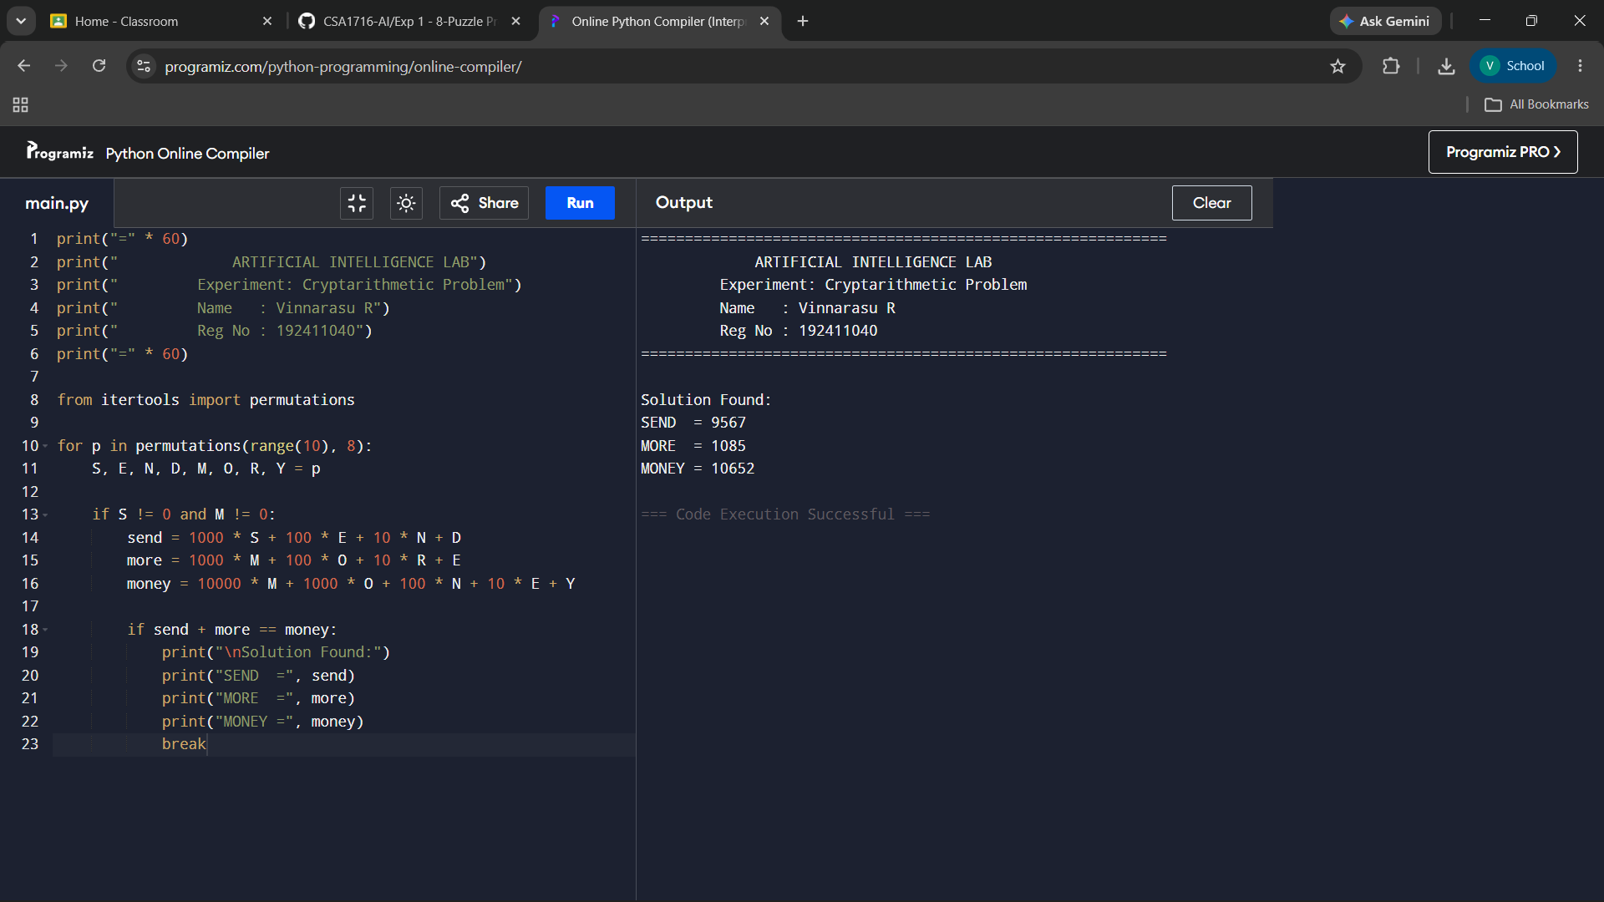
Result:
The Crypt Arithmetic problem was successfully solved using Python. The program assigned unique digits to each letter and verified the equation SEND + MORE = MONEY, producing the correct solution.

